CMPE314 - SOFTWARE ENGINEERING
Lab 6: Data Flow Diagrams (DFDs) - FitTrack Solution
Project: FitTrack - Personal Fitness Companion
Chosen use case for Level 2: Manage Workouts. This use case was selected because it has clear data movement: the user enters workout information, the system validates it, stores it, allows deletion, and updates the dashboard and chart.

DFD Components for FitTrack
Component | FitTrack Example
External Entity | User
Main System Process | FitTrack System
Main Processes | Authenticate User, Manage Workouts, Manage Meals, Manage Goals, Generate Dashboard & Weekly Chart
Data Stores | D1 User Accounts, D2 Workout Logs, D3 Meal Logs, D4 User Goals
Main Outputs | Login result, Today's Snapshot, Weekly Chart, saved workout/meal lists, error messages

1. Context Diagram - Level 0 DFD
This diagram shows the FitTrack system as one main process. The user sends credentials, workout data, meal data, and calorie goals. FitTrack reads and writes localStorage data stores, then returns dashboard results, charts, and messages.
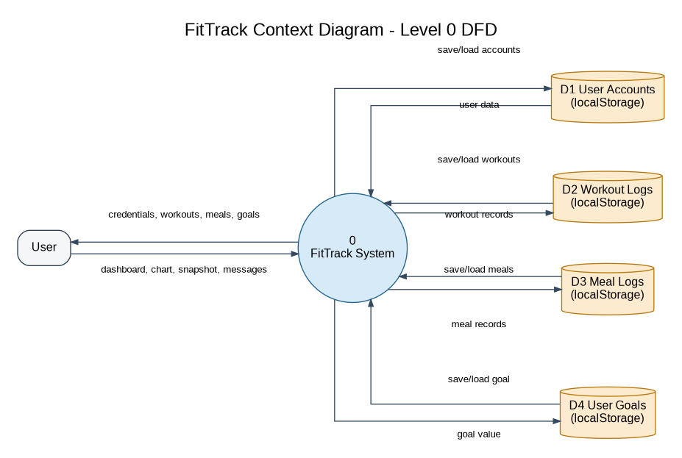

2. Level 1 DFD
This diagram decomposes FitTrack into five main processes: authentication, workout management, meal management, goal management, and report generation. The dashboard process reads workout, meal, and goal data to create the weekly chart and today snapshot.
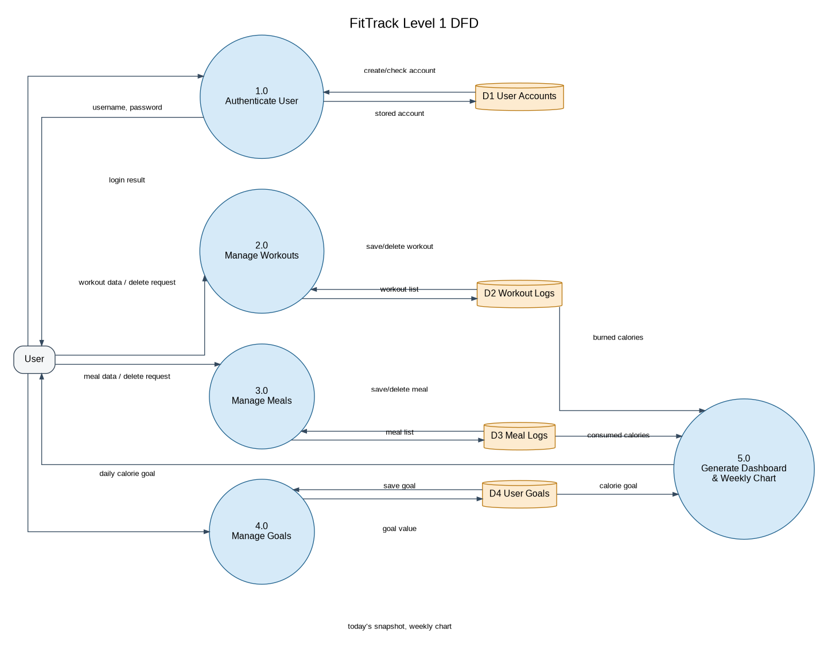

3. Level 2 DFD - Manage Workouts
This diagram expands Process 2.0 Manage Workouts. Workout details are entered, validated, saved to the workout data store, or deleted. After saving or deleting, the dashboard data is refreshed.
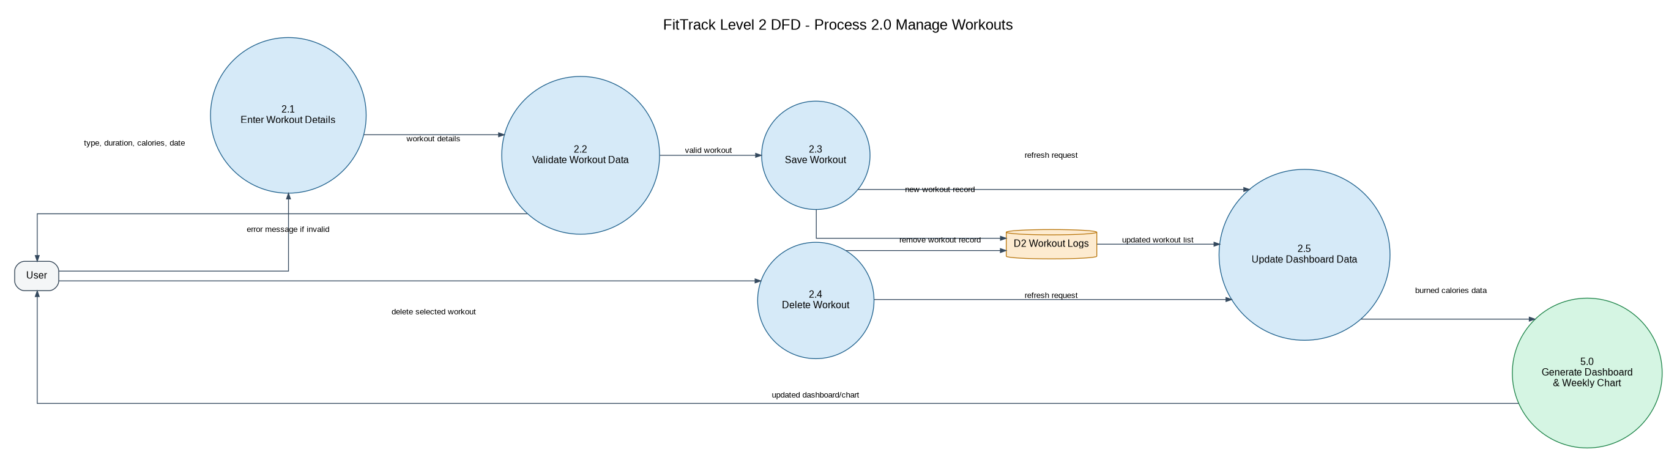

Brief Explanation
The context diagram presents FitTrack as a single system and shows how the user exchanges information with it. The Level 1 DFD breaks the system into the major functions used in the project report: authentication, workouts, meals, goals, and dashboard reporting. The Level 2 DFD focuses on Manage Workouts and shows the detailed steps from entering data to validation, storage, deletion, and dashboard update.

Submission Items Included
- Context Diagram / Level 0 DFD
- Level 1 DFD
- Level 2 DFD for Manage Workouts
- Component list and short explanation

